**INFO8980 – Final Exam**

[](https://employeeportal.conestogac.on.ca/CourseOutlineAccessible/CourseOutline/Index/CRSCode%5EINFO8980~CRSTitle%5E~ACYId%5E32~CRSVersion%5E100~OutlineID%5E123877" \t "_blank)

**1. UX Strategy**

**Description:**

LOOP is an eco-friendly bike-sharing mobile application designed to revolutionize urban transportation by providing a convenient, cost-effective, and environmentally conscious solution. The app aims to make bike rentals user-friendly and accessible while promoting sustainability and reducing carbon footprints.

**UX Objectives:**

**User-Centric Design:**  
Craft an intuitive and seamless experience that simplifies bike-sharing, catering to diverse user needs and preferences.

**Inclusive Accessibility:**  
Ensure the app adheres to accessibility guidelines, providing equal usability for individuals with disabilities through high contrast, scalable text, and assistive technologies.

**Optimized Efficiency:**  
Enable users to perform essential actions, such as bike reservations, route planning, and payments, quickly and effortlessly.

**Engaging Experience:**  
Deliver visually appealing and interactive designs, leveraging dynamic maps, real-time updates, and engaging animations to maintain user retention and satisfaction.

**Sustainability Focus:**  
Promote eco-friendly transportation by highlighting sustainable routes, carbon savings, and the environmental benefits of choosing LOOP over other modes of travel.

**2. Prototyping**

**Interactive Prototype Overview:**

The **LOOP** prototype is developed in Adobe XD, showcasing all key functionalities and interactions to simulate a realistic user experience. Advanced interactions and accessibility features were integrated to ensure inclusivity and usability.

**Key Screens:**

1. **Onboarding and Registration:**
   * Intuitive onboarding process.
   * Secure login and account creation with email verification.
2. **Home Screen:**
   * Displays nearby bikes with real-time availability and pricing.
   * Search functionality with filters for stations, bike features, and locations.
3. **Trip Management:**
   * Interactive map with start and end location inputs.
   * Real-time trip tracking and estimated arrival times.
4. **Route Planning:**
   * Provides eco-friendly, scenic, and fastest route options.
   * Displays estimated travel times and distances for each route.
5. **Station Information:**
   * Real-time data on bike and dock availability.
   * Integration with public transport stations for seamless transfers.
6. **Payment and Cost Management:**
   * Subscription plans and top-up options.
   * Secure payment methods with detailed transaction summaries.

**Advanced Interactions:**

* QR code scanning for bike unlocking.
* Real-time updates for bike and dock availability.
* Animated transitions between screens for smooth navigation.

**3. Sketches**

**Sketching Process:**

Sketches served as the foundation for visualizing the app's design and functionality. Each sketch was annotated to provide clarity on:

* Key features like buttons and interactive elements.
* Accessibility considerations, including high contrast and large text sizes.
* Navigation flows between screens.
* Home Screen: Includes filters, bike availability, and booking options.
* Trip Management: Highlights route selection and trip tracking features.

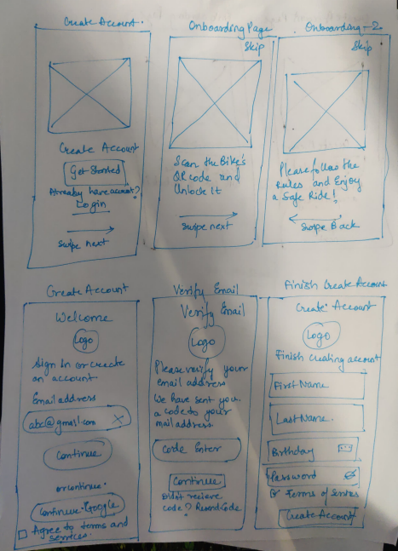

|  |
| --- |
|  |
|  |
|  |
|  |
|  |
|  |
|  |
|  |
|  |
|  |
|  |
|  |
|  |
|  |
|  |

**4. Wireframes**

**Wireframe Details:**

Low-fidelity wireframes were created to outline the core layout and functionality of the app. These wireframes helped refine the design before moving to high-fidelity prototypes.

**Key Wireframe Features:**

* **Home Screen:** Displays bike availability and filters.
* **Payment Screen:** Includes top-up and payment method options.
* **Route Map:** Shows detailed paths with time and distance estimations.

|  |  |
| --- | --- |
|  |  |
|  |  |
|  |  |
|  |  |
|  |  |
|  |  |
|  |  |
|  |  |
|  |  |
|  |  |
|  |  |
|  |  |

**5. Interactive Prototypes**

**Features Demonstrated:**

1. Smooth navigation between app screens.
2. Real-time updates for bike and dock availability.
3. Advanced functionalities like QR code scanning and dynamic trip tracking.
4. Accessibility features, including keyboard navigation and screen reader compatibility.

**Prototype Highlights:**

* Fully functional navigation.
* Dynamic updates on trip progress and station availability.
* Engaging animations for transitions between screens.

|  |  |  |
| --- | --- | --- |
|  |  |  |
|  |  |  |

|  |  |
| --- | --- |
|  |  |
|  |  |
|  |  |
|  |  |
|  |  |
|  |  |
|  |  |
|  |  |
|  |  |

**6. Addressed Design Challenges**

**1. Trip Management**

**Challenges:**

* Enable users to start and end trips seamlessly.
* Provide real-time tracking and notifications for trip events, such as start, end, and overage fees.

**Solutions:**

* **QR Code Scanning:** Implemented a **QR Code Scanner** for unlocking bikes. Users can also manually enter a **Bike ID** as a fallback option, ensuring flexibility and accessibility.
* **Real-Time Notifications:** Users receive visual updates on the trip status, such as:
  + **Trip Started:** Displayed as soon as the QR code is scanned, showing the route and estimated time to destination.
  + **Overage Fees and Costs:** Transparent cost breakdown displayed in the **Trip Summary** and **Receipt Page** to notify users of extra charges incurred during the trip.
* **Trip Progress:** Real-time tracking on a dynamic map, showing time, distance, and route navigation, with updates throughout the journey.

**2. Route Planning**

**Challenges:**

* Provide diverse route options, such as eco-friendly and scenic paths, alongside the fastest route.
* Deliver real-time updates on traffic conditions and travel times.

**Solutions:**

* **Route Options:** Users can select from multiple route types (eco-friendly, scenic, or fastest), displayed on an interactive map.
* **Real-Time Updates:** Routes update dynamically based on real-time traffic data, ensuring accurate **Estimated Arrival Times** (ETA).
* **Distance and Duration:** The route map provides clear visual indicators of travel distance and time, helping users plan effectively.
* **Tourist-Friendly:** Scenic routes are highlighted to promote local sightseeing and encourage eco-tourism.

**3. Station Information**

**Challenges:**

* Provide users with real-time data on bike and dock availability.
* Integrate with public transportation to enhance accessibility.

**Solutions:**

* **Station Availability:** Each station’s card displays:
  + The number of available bikes and free docks.
  + Visual indicators (e.g. icons or color-coded markers) to show station status briefly.
* **Integration with Public Transport:** Stations near subway or bus stops are highlighted with transport icons, ensuring seamless multimodal connectivity.
* **Station Details:** Users can view station-specific information, including addresses and nearby landmarks, on the **Station Information Screen.**

**4. Payment and Cost Management**

**Challenges:**

* Offer flexible payment options and transparent cost breakdowns.
* Introduce subscription plans and discounts for frequent users.

**Solutions:**

* **Subscription Plans:** Users can purchase weekly or monthly passes (e.g., **Weekly Pass for $27.98**) directly from the **Wallet Screen**.
* **Transparent Costs:** The **Payment Summary Page** clearly displays:
  + Base cost, additional fees, discounts, and total payment.
* **Multiple Payment Options:** The **Payment Screen** supports various methods, including:
  + Credit/Debit Cards (e.g., MasterCard).
  + Digital Wallets (e.g., Apple Pay, Loop Wallet).
  + Flexible Top-Up Options: Users can add funds in preset amounts ($5, $10, etc.).
* **Transaction History:** Users can access receipts with complete transaction details, ensuring transparency and trust.

1. **Design Analysis**

**Usability Heuristics Applied:**

* **Visibility of System Status:**
  + Real-time updates on trip progress and notifications.
* **Consistency and Standards:**
  + Uniform design elements such as buttons and icons across screens.
* **Error Prevention:**
  + Confirmation dialogs before critical actions, such as payments.

**UI Patterns Incorporated:**

* Card-based layouts for bike and station details.
* Floating action buttons for quick actions like booking.
* Sticky headers for consistent navigation.

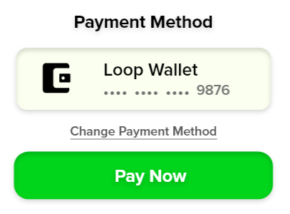

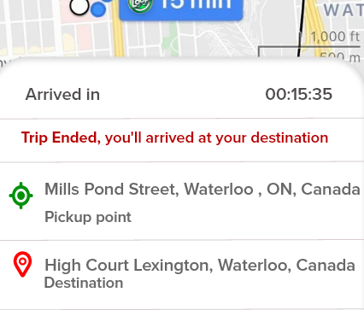

1. **Accessibility**

**Accessibility Features:**

1. **High Contrast:** Ensures readability for users with visual impairments.

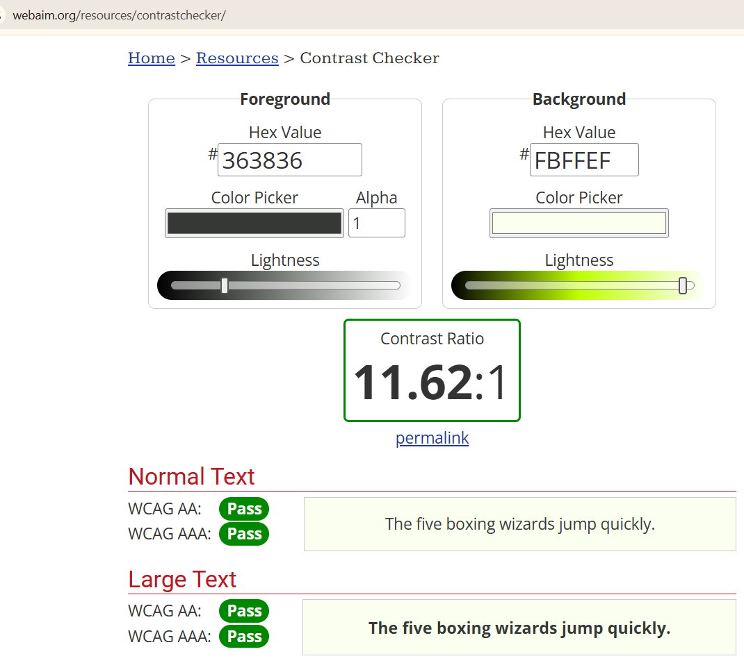

1. **Adjustable Text Size:** Allows users to customize text size for better visibility.

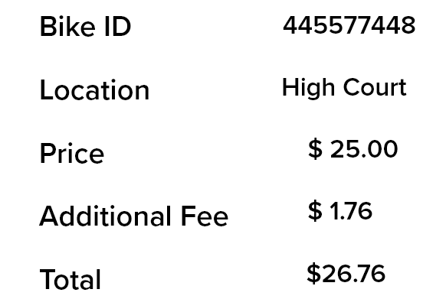

1. **Keyboard Navigation:** Ensures compatibility with keyboard-only interactions.
2. **Alt Text:** Provides descriptive text for all icons and images.

**Home Screen (Bike Nearby Section)**

* **Icons:** Alt text for filter and search icons, e.g.:
  + Search Icon: "Search for bikes, addresses, or stations"
  + Filter Icon: "Filter available bikes by features"

* **Images:** Descriptions for bike images:
  + "Gazzelle MT Bike, 250 meters away, $25/day, rated 4.7 stars"

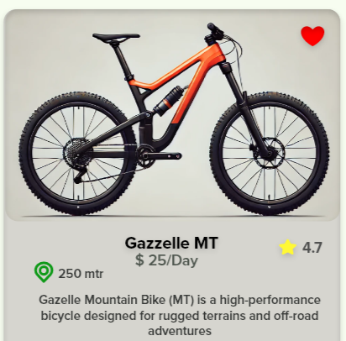

**Trip Management (Map Screen)**

* **Map Elements:** Alt text for interactive map points:
  + Start Location Pin: "Your starting location - Mills Pond Street"
  + End Location Pin: "Your destination - High Court Lexington"

**QR Code Screen**

* **QR Scanner Image:** Provide a description for the camera interface:
  + "Camera view with QR code scanner frame"

* **Input Field:** Label for the manual ID entry field:
  + "Enter Bike ID manually"

**Payment and Wallet Pages**

* **Icons and Buttons:** Alt text for payment options and wallet features:
  + "Payment method: Loop Wallet ending in 9876"
  + "Top-Up button to add funds to your wallet"

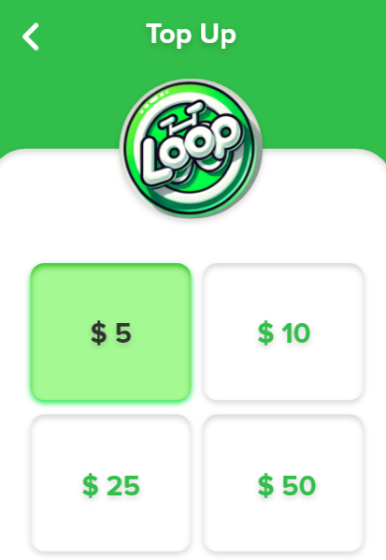

* **Subscription Images:** Provide descriptions for subscription plans:
  + "Weekly Pass for $27.98"

**Summary and Receipt Pages**

* **Icons:** Alt text for status badges:
  + "Payment successful icon, green checkmark badge"

* **Text Elements:** Alt text for transaction summaries:
  + "Transaction ID 4938 4537 2747, paid via credit card on 1 Sep 2024"

1. **Screen Reader Support:** Fully compatible with voiceover and screen reader tools.

**Example:** Buttons: "Start Trip" instead of "Click Here."

Input fields: Label like "Enter Bike ID" or "Search Address."

**Examples:**

* Payment screen with bold, legible text.
* Navigation buttons with clear and descriptive labels.